ASSIGNMENT-4
Single row function
1. Display the names, jobs and bonus for all employees assuming all managers get a bonus of Rs. 500,clerks get Rs.200 and all others except the president Rs.350. the president gets 20 percent of his salary as bonus.
A: SELECT ename,job ,CASE WHEN JOB='MANAGER' THEN 500 WHEN JOB='CLERK' THEN 200
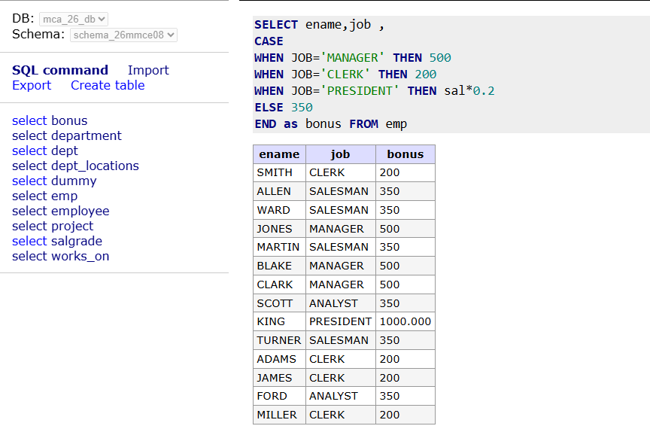
WHEN JOB='PRESIDENT' THEN sal*0.2 ELSE 350 END as bonus FROM emp;
2. Display the names of all employees and their bonus. Assume each employee gets
a bonus of 20 percent of his salary subject to the maximum of Rs. 200.
A: SELECT ename,case when sal*0.2<200 then sal*0.2 when sal*0.2>200 then 200 end as bonus FROM emp
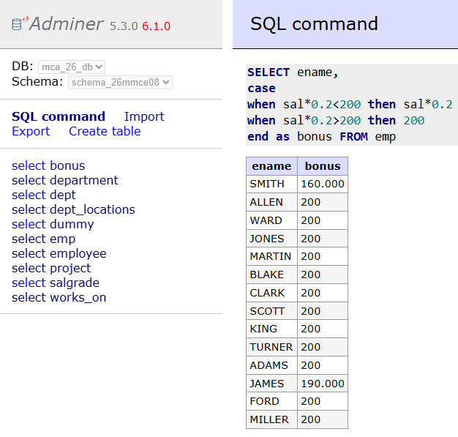
3 .Display the employee details in the following manner. „Miller joined on the twenty third of January of the year eighty second‟.
A: SELECT ENAME || ' joined on the ' || TO_CHAR(HIREDATE, 'DDth "of" Month "of" YYYY') AS DETAILS FROM EMP;
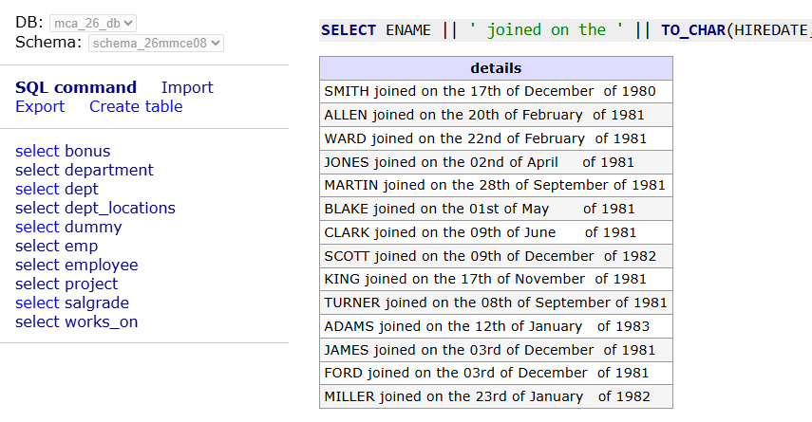
4. Display the name of all employees, and „Greater‟ or „smaller‟ depending on where the salary of the employees is greater than or less than 1500.
A: SELECT ENAME, SAL,
CASE WHEN SAL > 1500 THEN 'Greater'
ELSE 'Smaller'
END AS RESULT FROM EMP;
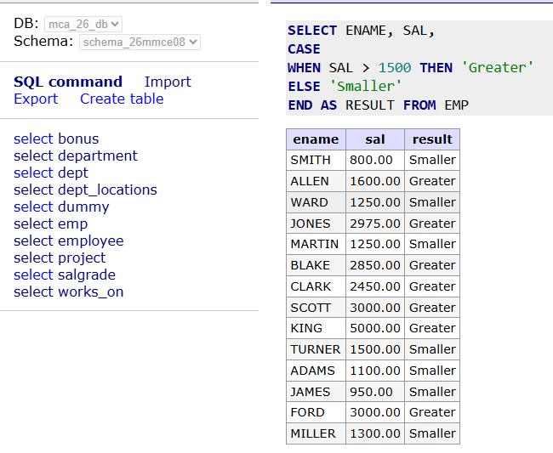
5. Display the DA of all employees and calculation is in the following manner
If salary >=5000 then DA is 75% of Salary
If salary >=3000 and salary
A: SELECT ENAME, SAL,
CASE
WHEN SAL >= 5000 THEN SAL * 0.75
WHEN SAL >= 3000 THEN SAL * 0.60
ELSE SAL * 0.50
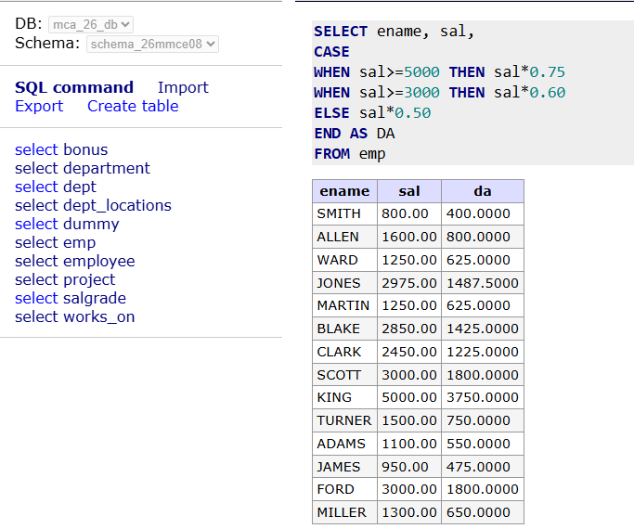
END AS DA
6. Display the names, job and hire date of employees with there hire dates in desc order inside each department.
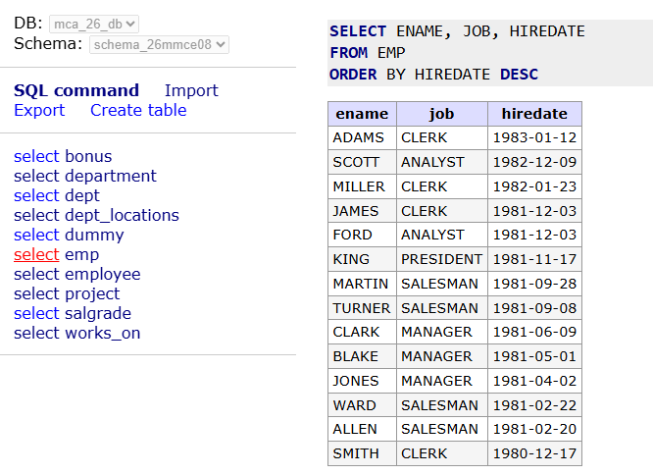
A: SELECT ENAME, JOB, HIREDATE
FROM EMP
ORDER BY HIREDATE DESC;
7. What would be the date after two months?
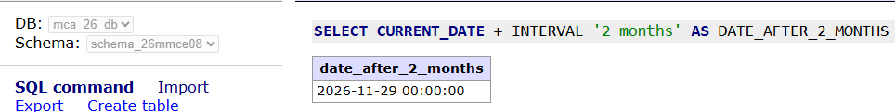
A: SELECT CURRENT_DATE + INTERVAL '2 months' AS DATE_AFTER_2_MONTHS;

8. List the employee number, name of all employees Employee names should have only the first letter in upper case and department no in descending order.
A: SELECT EMPNO,
INITCAP(ENAME),
DEPTNO
FROM EMP
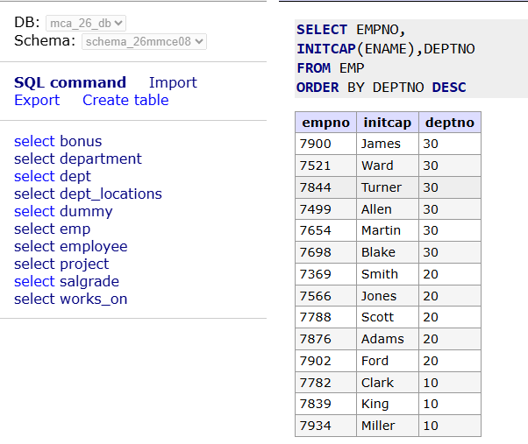
ORDER BY DEPTNO DESC;

9. Concatenate the name of the person with his job separated by three spaces (CONCAT).
A: SELECT CONCAT(ENAME, ' ', JOB) FROM EMP;
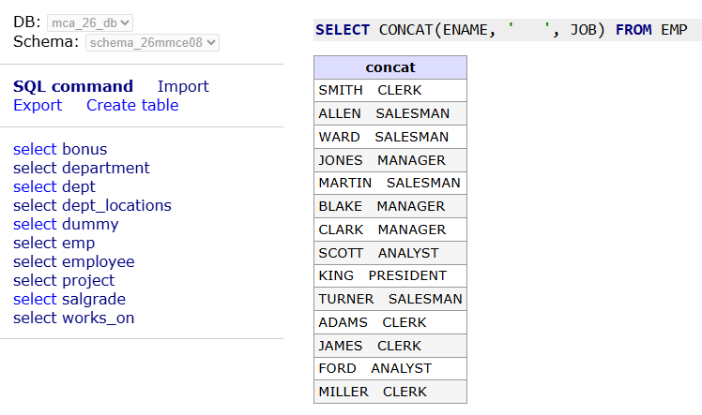
10. Display the names of all employees, padding them to the right up to 16 characters with.
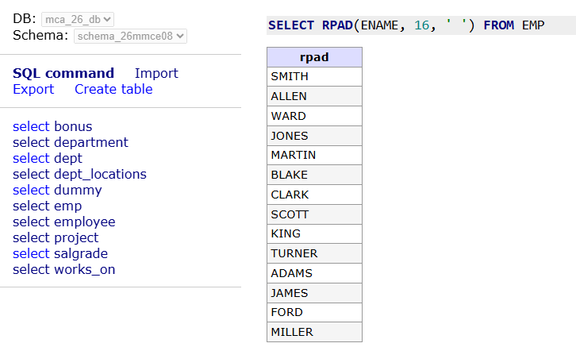
A: SELECT RPAD(ENAME, 16, ' ') FROM EMP;

11. Show the first three characters of names of all employees.
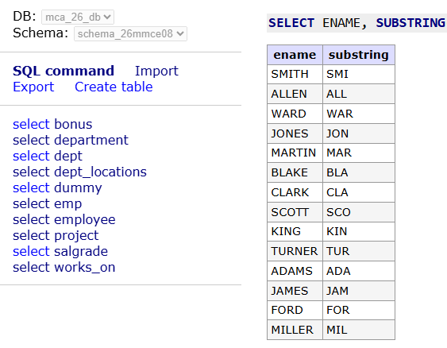
A: SELECT ENAME, SUBSTRING(ENAME FROM 1 FOR 3) FROM EMP;
12. Find the salary of all employees rounding it to the nearest Rs.1000.
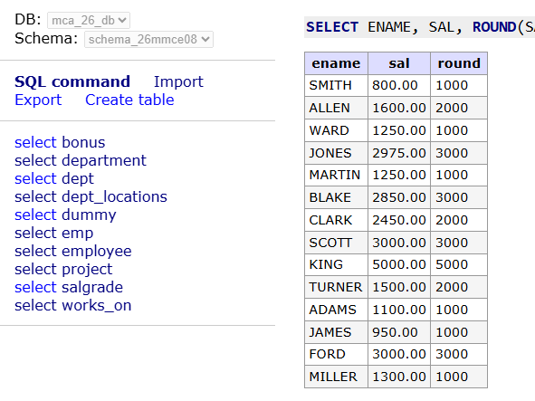
A: SELECT ENAME, SAL, ROUND(SAL, -3) FROM EMP;

- Find employees name and job whose employees names last character is equal to jobs last character.
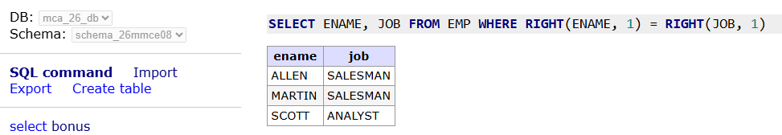
A: SELECT ENAME, JOB FROM EMP WHERE RIGHT(ENAME, 1) = RIGHT(JOB, 1);

- Display the names and salary of the employees in the descending order of their income.
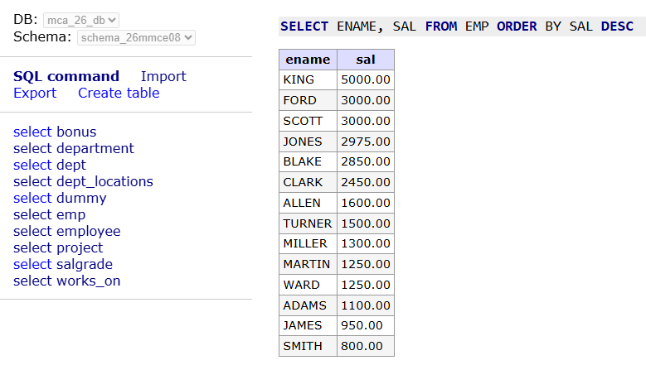
A: SELECT ENAME, SAL FROM EMP ORDER BY SAL DESC;

- Display the names of all employees with any „A‟ at any place of the name.
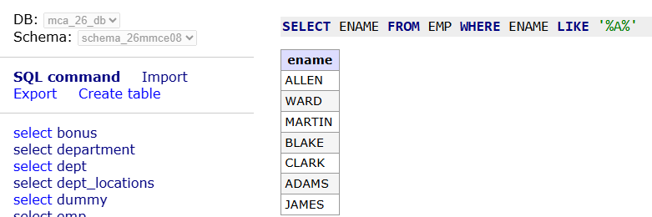
A: SELECT ENAME FROM EMP WHERE UPPER(ENAME) LIKE '%A%';

- Show all employees who were hired in the first half of the month (Before the 16th of the month).
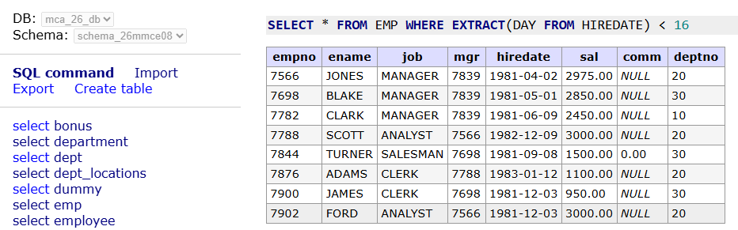
A: SELECT * FROM EMP WHERE EXTRACT(DAY FROM HIREDATE) < 16;

- Show all employees, and indicate with “YES” or “NO” whether they receive a commission.
A: SELECT ENAME, COMM,
CASE
WHEN COMM IS NULL THEN 'NO'
ELSE 'YES' END FROM EMP;
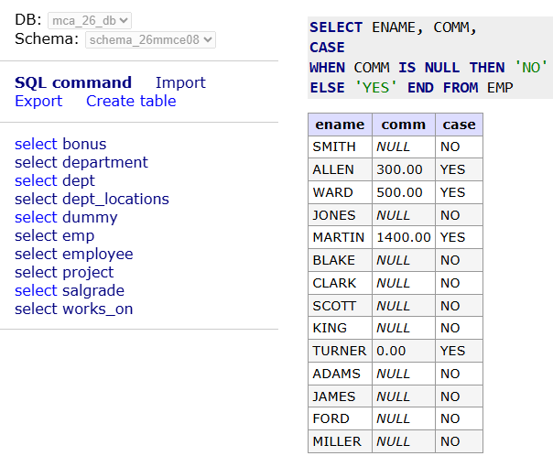

- Show those employees that have a name starting with J, K, L, or M.
A: SELECT ENAME
FROM EMP
WHERE UPPER(ENAME) LIKE 'J%'
OR UPPER(ENAME) LIKE 'K%'
OR UPPER(ENAME) LIKE 'L%'
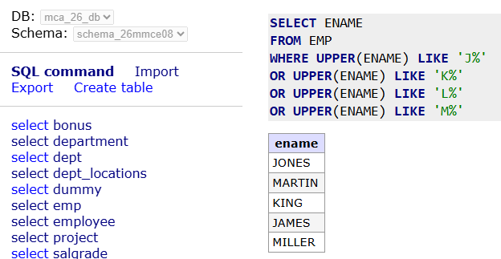
OR UPPER(ENAME) LIKE 'M%';

- Display the length of all employees.
A: SELECT ENAME, LENGTH(ENAME) FROM EMP;
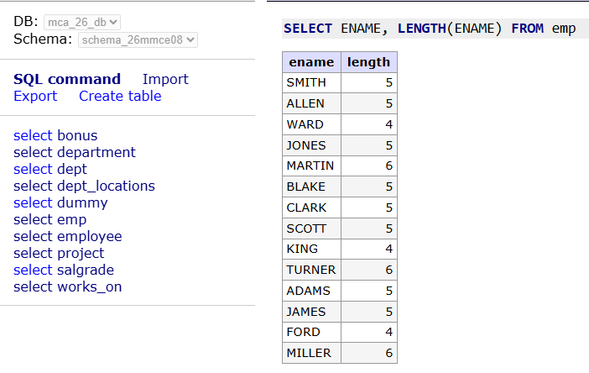

- Display the name and job of all employees who do not have a manager.
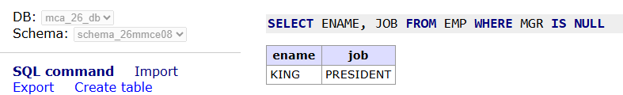
A: SELECT ENAME, JOB FROM EMP WHERE MGR IS NULL;

- Find all employees whose name are 5 characters long and end with „N‟.
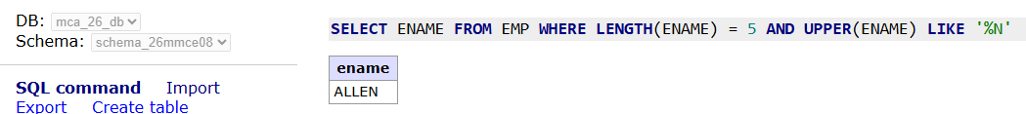
A: SELECT ENAME FROM EMP WHERE LENGTH(ENAME) = 5 AND UPPER(ENAME) LIKE '%N';

- Display the employee name and department no of all employees in department 10,30 in alphabetical order by name.
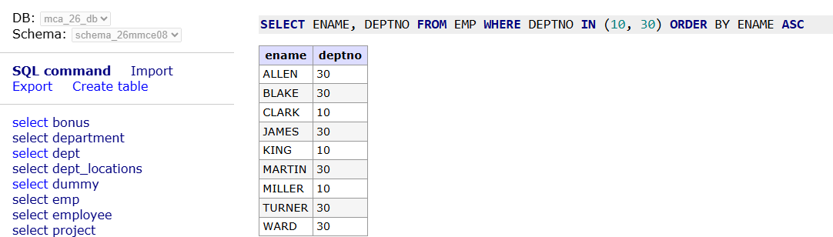
A: SELECT ENAME, DEPTNO FROM EMP WHERE DEPTNO IN (10, 30) ORDER BY ENAME ASC;

- Find employees who do not receive a commission or whose commission is less than Rs.100. (comm. Is null or comm. < 100)
A: SELECT ENAME, COMM FROM EMP WHERE COMM IS NULL OR COMM < 100;
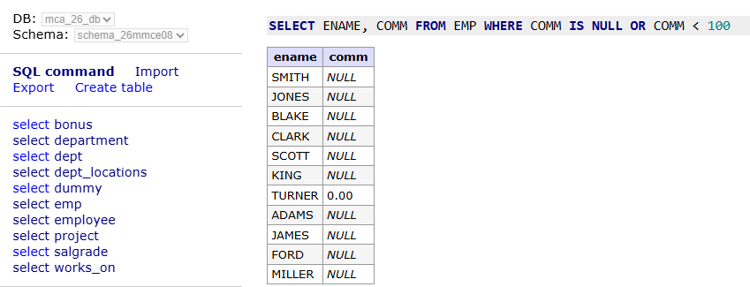
- Find the employees whose commission is Rs.0.
A: SELECT ENAME, COMM FROM EMP WHERE COMM = 0;
